Acadia University

DVD Store Project | Artifacts

AJ Blooi (100143069) | Contribution: 33%

David LeBlanc (100143807) | Contribution: 34%

Elianna McKinnon (100142090) | Contribution: 33%

COMP 2663 X2  
Haiyi Zhang

Submitted: April 2nd, 2019

**List of Material:**

* How to use our DVD Store Database
* Sequence Diagrams
  + Stock DVD
  + Search DVD
  + Return DVD
  + Rent DVD
  + Search Customer
  + Register Customer
* Design Class Diagram
* Use Case Diagram
* Use Case Diagram Description

**How to use our DVD Store Database**

* Compile SystemUI.java in the same folder as the other files to have the database open up. There are some pre-set movies and customers already registered in the database.
* Have a choice of 5 tabs to interact with in the system UI:

1. **Customer Search**
   1. Can search for a customer profile in the database either by address, name or phone # by filling in the empty text field and a customer profile will appear. Attempted searches will not work if text field is empty.

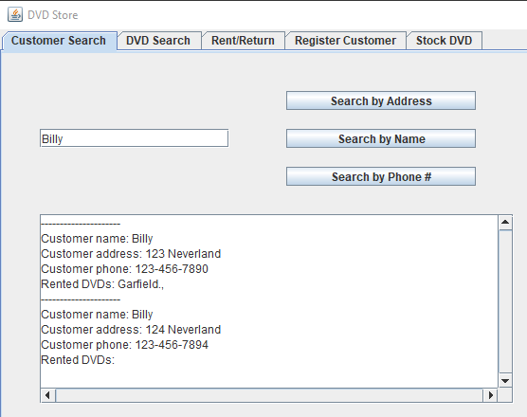

1. **DVD Search**
   1. Similar format to customer search, instead can search for DVD by name, genre or director and a DVD profile will appear. Attempted searches will not work if text field is empty.

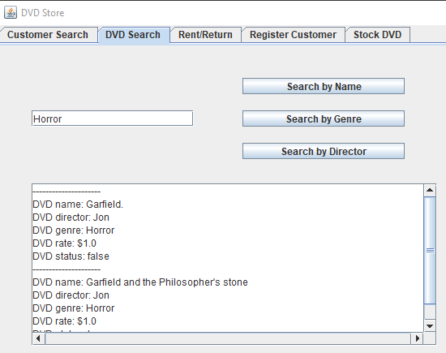

1. **Rent/Return**
   1. Can either rent or return a DVD by entering a customer’s phone number and a DVD name. Both these pieces of information should already exist in the database, or else it will not work.

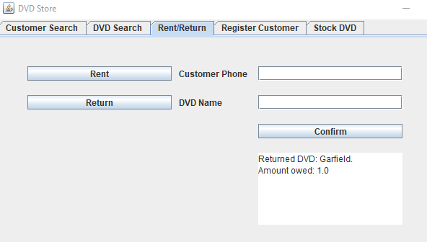

1. **Register Customer**
   1. This tab can register a customer into the database by address, phone number, and name. Once confirmed, the customer can then be located in the database in the customer search tab. Registration will not work if any of the fields are empty.

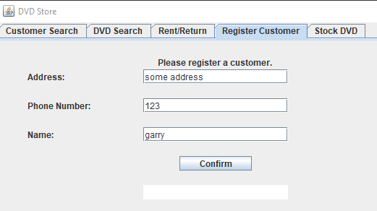

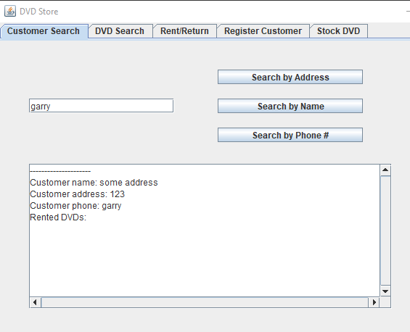

1. **Stock DVD**
   1. A DVD can be stocked by name, director, genre and price. The stocking process will not work if any of the fields are empty.

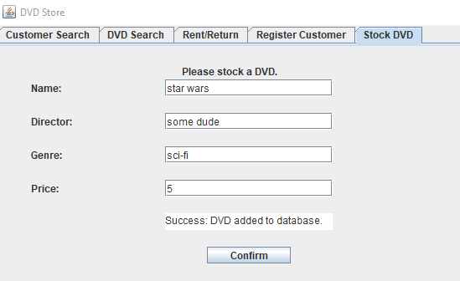

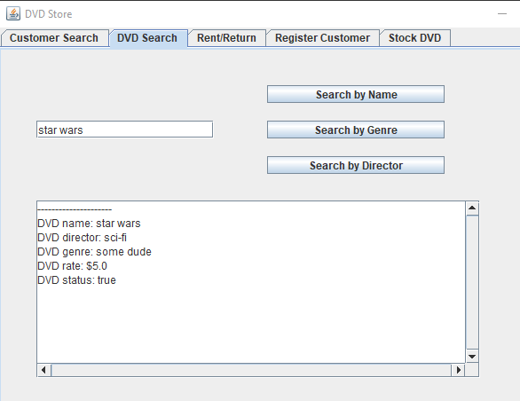

1. **Quit**
   1. This is the way that the database can close and securely save its data for the user. If exited by the “X” in the very top right corner, the information processed during the session will be lost.

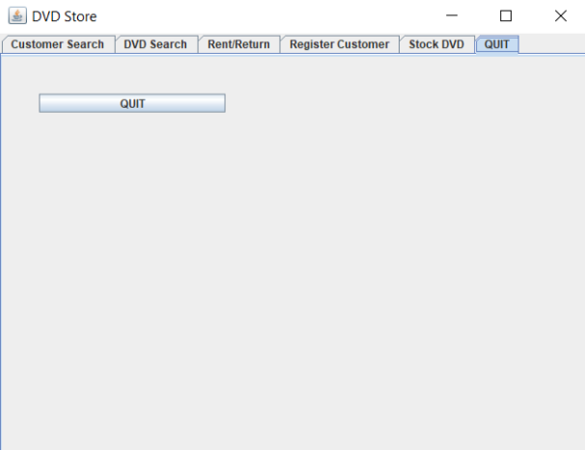

**Sequence Diagram**

Stock DVD

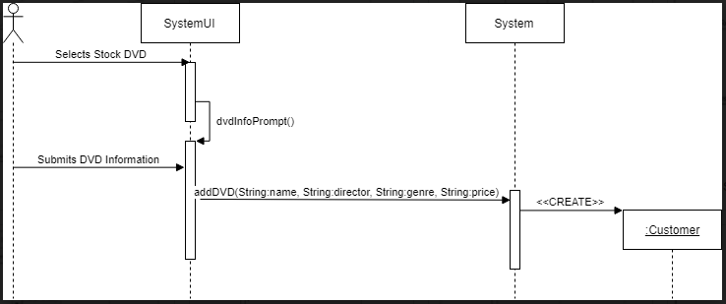

Search DVD  
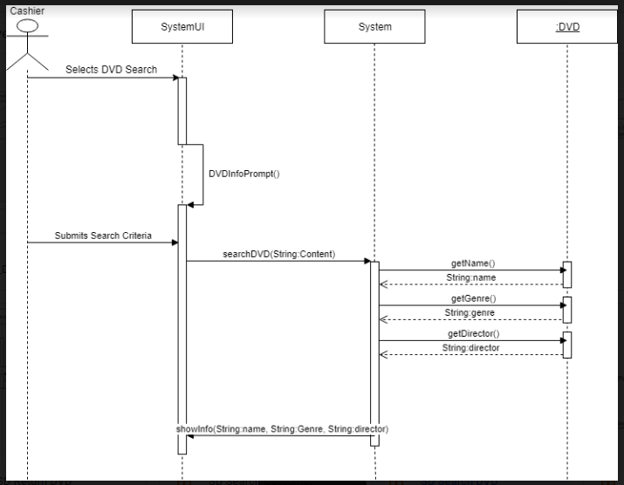

Return DVD

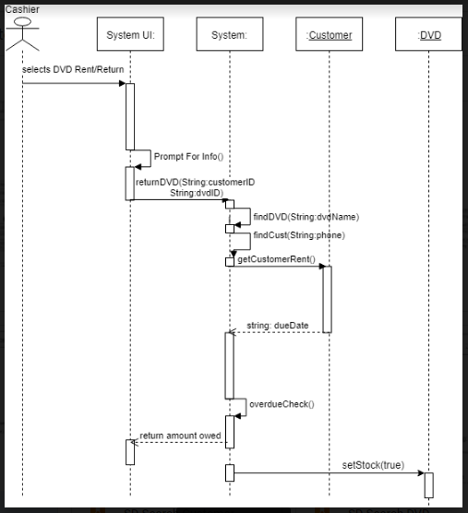

Rent DVD

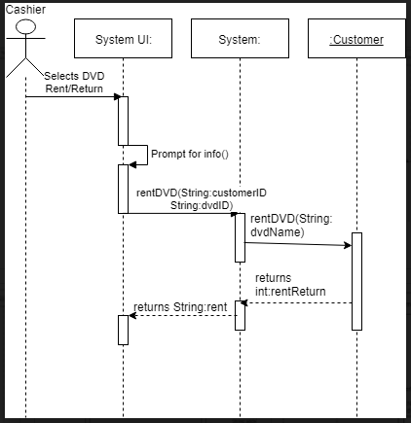

Search Customer

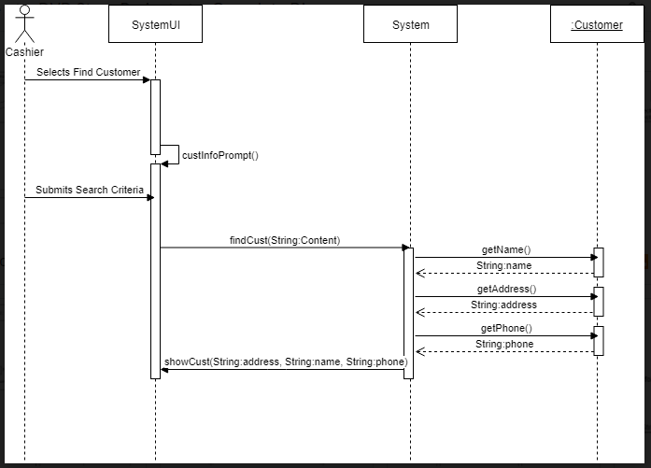

Register Customer

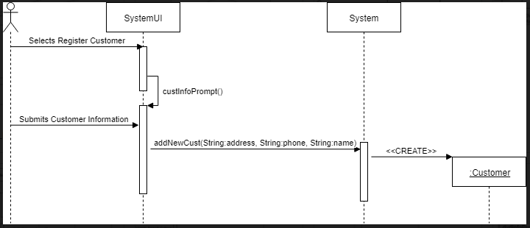  
  
**Design Class Diagram**

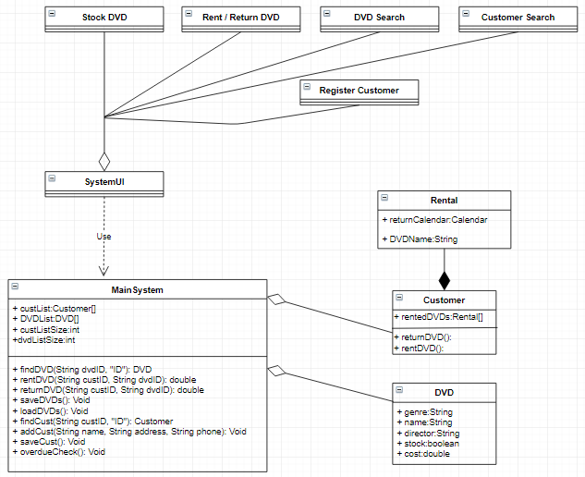

**Use Case Diagram**

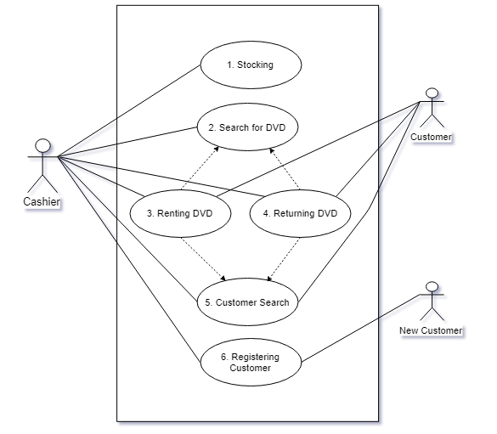

**Use Case Diagram Description**

**1.) Stocking DVD**

I.) System displays main menu.

II.) Cashier chooses Stock DVD option.

III.) Cashier stocks DVD by name, genre, director, and rental price.

IV.) System stores data.

**2. Search for DVD**

I.) System presents main menu

II.) Cashier selects DVD Search

III.) Cashier enters name of DVD, Director or genre

IV.) System displays results by entered data.

**3. Renting DVD**

I.) System presents main menu

II.) Cashier selects Rent / Return label

III.) cashier selects rent or return button

III.) Cashier searches for DVD by DVD name and customer’s phone number.

IV.) Cashier confirms option, system confirms DVD is returned then displays amount owed.

**4.) Returning DVD**

I.) System displays main menu.

II.) Cashier chooses Rent / Return label

III.). Cashier selects rent or return button

IV.) Cashier searches for DVD by DVD name and customer’s phone number.

V.) Cashier confirms option, system confirms DVD is returned then displays amount owed.

**6. Customer Search**

I.) System presents main menu

II.) Cashier clicks "Customer Search" label

III.) System presents customer search sub-menu, contains fields for relevant customer information along with search buttons for each (so the cashier may search by name, address etc.)

IV.) Cashier fills the field of data and clicks one of the adjacent "Search" button.

V.) System displays a list of customers with that information stored in their account.

VI.) If more then one Customer show up they enter address or phone #

VII.) System displays customer information.

**7.) Registering a customer**

I.) System presents main menu

II.) Cashier clicks "Register Customer" label

III.) System presents register customer sub-menu, contains fields for pertinent customer information.

IV.) Cashier fills out fields with the customer's new information.

V.) Cashier clicks "confirm" button to complete process.